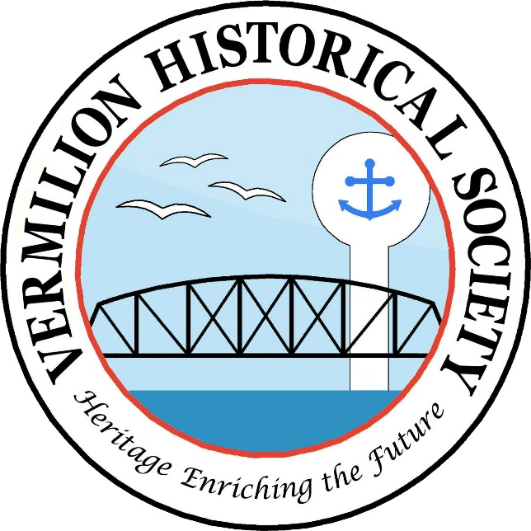

Membership Dues for Vermilion Historical Society
501(c)(3) non-profit organization

Name: ___________________________________________ Circle One:
Single $15.00
Address: _________________________________________ Couple $25.00
Life $100.00
City/State/Zip: ____________________________________ Student $5.00

Phone: _____________________ Email: ___________________________________

In addition, please accept my donation: $25 $50 $100 Other $______

Amount Enclosed: _________________

Please make check payable to VAAS and mail to:

Vermilion Area Archival Society
c/o Ritter Public Library
5680 Liberty Avenue
Vermilion, OH 44089

All donations are tax deductible to the extent permitted by law.

Thank you for your support!

